Name:Kannan N
Reg No:212223230097

Python Task

1.Search Engine Automation Using Selenium

from selenium import webdriver
from selenium.webdriver.common.by import By
from selenium.webdriver.common.keys import Keys
import time

driver = webdriver.Chrome()

driver.get("https://www.google.com/")

search = driver.find_element(By.NAME, "q")

search.send_keys("Actor Suriya")

print(search.get_attribute("value"))

search.send_keys(Keys.ENTER)

time.sleep(3)

Output:
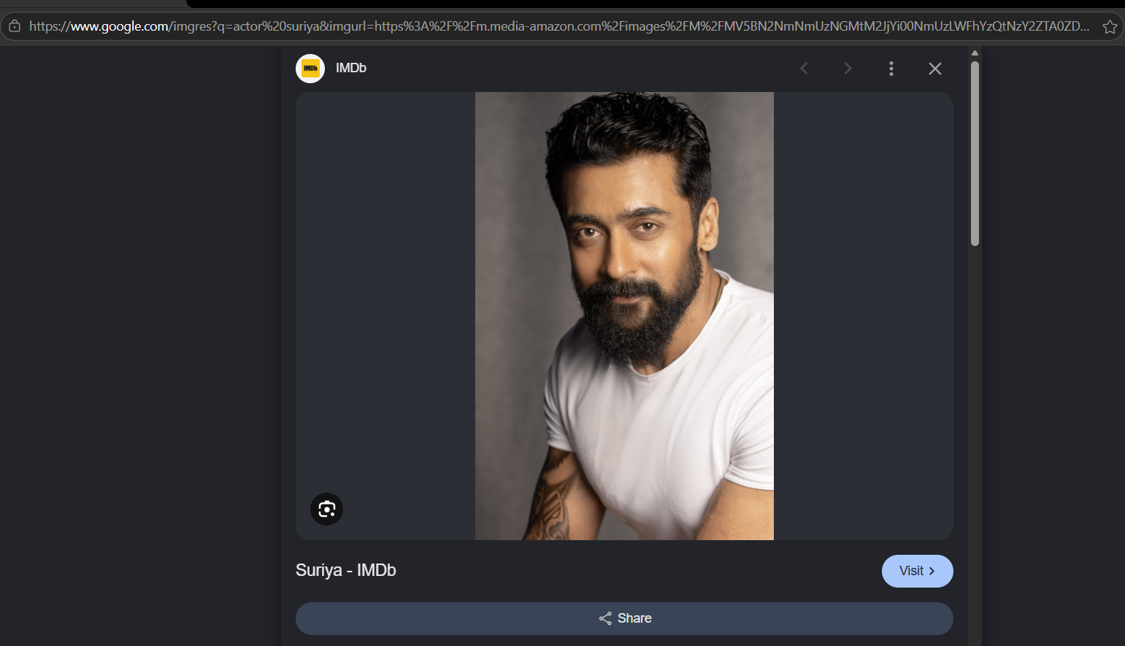

2.Sauce Website Product Search Automation Using Selenium

from selenium import webdriver
from selenium.webdriver.common.by import By
import time

driver = webdriver.Chrome()

# Open SauceDemo
driver.get("https://www.saucedemo.com/")

driver.maximize_window()

# Login
driver.find_element(By.ID, "user-name").send_keys("standard_user")
driver.find_element(By.ID, "password").send_keys("secret_sauce")

driver.find_element(By.ID, "login-button").click()

time.sleep(3)

# Find a product
product = driver.find_element(
By.XPATH,
"//div[text()='Sauce Labs Backpack']"
)

# Click the product
product.click()

print("Product opened successfully")

time.sleep(5)

driver.quit()

Output:
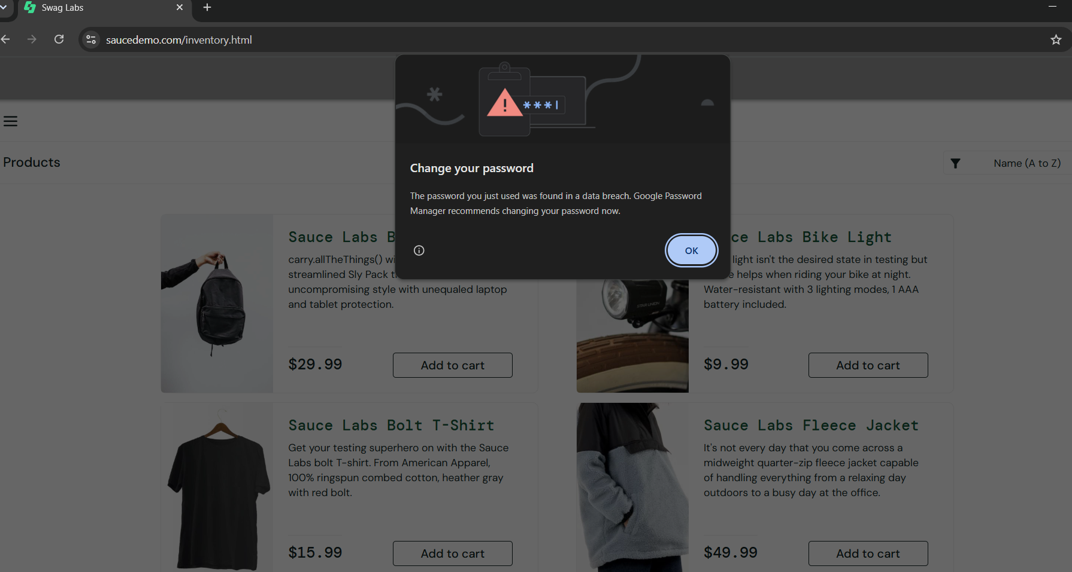

3.Flipkart Login Automation Using Selenium

from selenium import webdriver
from selenium.webdriver.common.by import By
from selenium.webdriver.support.ui import WebDriverWait
from selenium.webdriver.support import expected_conditions as EC
import time

driver = webdriver.Chrome()
driver.maximize_window()

wait = WebDriverWait(driver, 20)

driver.get("https://www.flipkart.com/")

login = wait.until(
EC.element_to_be_clickable(
(By.XPATH, "//span[contains(text(),'Login')]")
)
)
driver.execute_script("arguments[0].click();", login)

time.sleep(3)

mobile = wait.until(
EC.element_to_be_clickable(
(By.XPATH, "//input[contains(@placeholder,'Mobile') or contains(@placeholder,'mobile')]")
)
)

# Click the field first
mobile.click()

# Enter your number
mobile.send_keys("9566904599")

print("Mobile number entered!")

time.sleep(10)

Output:

